1 August 2026
Market Validation - Hans Shakur

Consumer vs customer

Observe what the people currently do
Interview after obvservation, ask people to explain their behaviour
Broad market validation - mvp and/or questionaire

Mvp: not necessarily a working product but maybe rather a presentation, it is a part of validation learning about customers, more so a Minimum Viable Product Presentation - easiest test for a particular hypthesis

Customers dont buy products, the buy va;ure proposition
The product is the vehicle by which the value proposition is delivered

Talking to the customers is the most effective underutilized technique

The mom test
Search for business failure points

Customer interviews done right:
3 step process
- get facts not opinions
- Pains
- deduce
- Validate solution

Ground rules for interviewing
- Adopt a beginners mind: Avoid interpretation, Explore unexpected jobs, pains relations, DIG IN into things you don’t understand or grasp fully. Tell me a story about..? What was hard? Why was it hard? How do you solve it now? Why is that not awesome?*
- Get facts, not opinions: don’t ask “would you..?”, Ask: “when is the last time you have..” → past and present qs not future
- Ask ‘why“ to get real motivatons: why do u need to do? Why is x important to you? Why is x such a pain - 5y rule - Symptom or phantom need to get to the root or real problem.
- The goal is learning, not selling: NO PITCHING
- Follow up: get permission to keep interviewee’s contact info to come bacl for more questions
- Open doors: always open doors at the end, ask: who else should i ask?

Bonus: emotions, 3-peat*, 5-why’s

Useful resources: Book: talking to humans, slideshare: Shut the hell up, the lean startup Eric Ries

SmartShelf: What is your problem? And why is your customer? Is it better to sell it to the POS company owner or to the business owners themselves? If we only sold it to two businesses and the pos system sees it, they can just reverse engineer it and boom they added it as a feature to their system, but if you sold it to them you can pitch it and you can run together.
We need to validate with different business owners and check where they share the need for it and where they differ, is your problem an actual pain in the market, or is it a pain for a specific customer.

Surveys
Online Surveys come after some physical convos to validate the target audience

- Excellent for quantitative data (percentages and so on), unlike speaking with people which is good for qualitative data, insights from stakeholders, emotions
- Need to know what to ask first
- Can be online or physical
- DIY forms, audience or online panels (communities, facebook, focus group panels)
- Integrated survey platforms.. Market research platforms..agencies

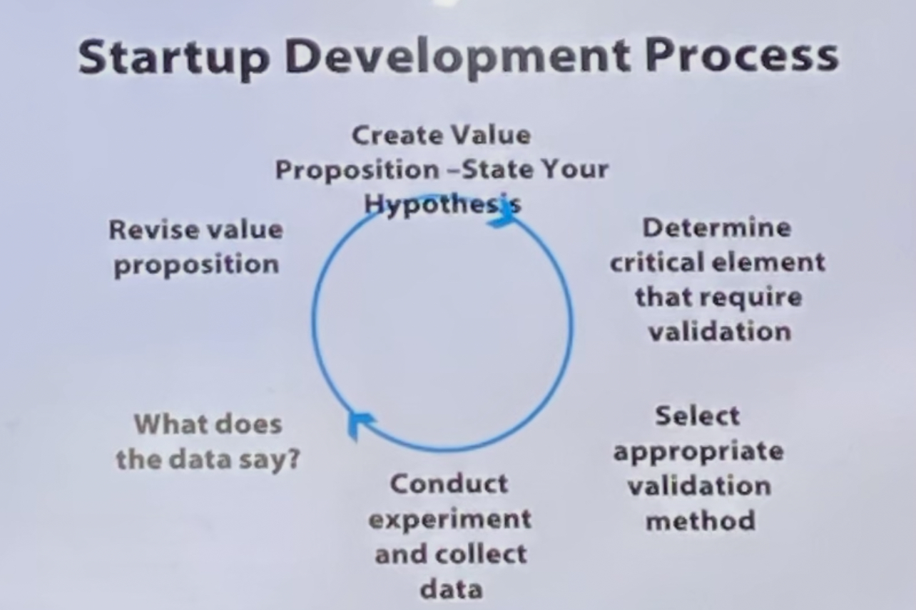
Mvp solutions
- Wizard of oz approach: zappos.com
- a/b testing
- Prototype
- ….
